**A**

**PROJECT REPORT**

**ON**

**Easy Study Portal**

**Prepared by**

**Dharma Bagadia(21IT004)**

**Vatsal Bhatt(21IT011)**

**Riya Bhimani(21IT012)**

**Information Technology**



**Charotar University of Science and Technology (CHARUSAT)**

**Declaration**

I hereby declare that the project report entitled “**Easy Study Portal**” submitted by me to Chandhubhai S Patel Institute of Technology, Changa in partial fulfillment of the requirement  for the award of the degree of **B.Tech** in Information Technology, from CSPIT, is a record of bonafide IT253 Software Group Project-1 carried out by me under the guidance of **Prof.Dhaval Patel** . I further declare that the work carried out and documented in this project report has  not been submitted anywhere else either in part or in full and it is the original work, for the  award of any other degree or diploma in this institute or any other institute or university.

**Dharma Bagadia(21IT004)**

**Vatsal Bhatt(21IT011)**

**Riya Bhimani(21IT012)**

**Prof.Dhaval Patel**

**Assistant Professor**

**Information Technology**

**CSPIT,Changa**

**ABSTRACT**

The present study is mainly based on online mode and it is easy to excess from anywhere. The aim of the easy study portal is to make the study material available online and it is useful to students of the colleges and school. With the advancement of technology, it is imperative to exalt all the systems in a user-friendly manner. The Easy Study Portal(ESP) acts as a tool to transform traditional study material into digital study material. This system is mainly used for the schools and colleges. In traditional study material, the students has to search for books which are hassle process. At the same time student has to visit the various store for the book. The overall progress of work is slow and it is impossible to generate a fast report. It is a tedious process to work simultaneously in different sectors. The single PC contains all the data in it. The admin has the main access of the system and provide an access to the all users . Through EPS user can find the book which they want . The ESP is designed with basic features such as the study material can be uploaded by the student and teacher also, if anyone wants to sell the book on second then it is also available. Once he/she ingress into the system they cannot change any data in the database. The complete model is developed using the Javascript, HTML, and CSS languages whereas the Firebase server is exploited as a database. The authorized person can only access the ESP system, they have to log in with their user id and password. The admin also has his / her administration enrollment number. As aforementioned, the ESP is designed in a user-friendly manner, so the admin can smoothly activate the system without expert advice. Every data is stored and retrieved from the Firebase database so it is highly secure. Thus our system contributes its new approach to the digital Study Material setup.

**TABLE OF CONTENTS**

Chapter 1 Introduction 6

* 1. Project Overview 7
  2. Objective 7
  3. Scope 8
  4. Tools and Technologies 8

Chapter 2 Project Management 9

* 1. Project Planning 10

2.2 Project Work Scheduling 11

Chapter 3 System Requirements Study 12

* 1. User Characteristics 13
  2. Hardware and software requirements 14
     1. Hardware Specifications 14
     2. Software Specifications 14

Chapter 4 implements tools for the project 15

* 1. Features of vs code 16
  2. Vs code project structure 16
  3. Vs code user interface…………………………………………………………..18

Chapter 5 System Design 20

* 1. Screen layout 21

Chapter 6 software testing 24

* 1. Why software testing is needed 26
  2. Testing strategy 26

6.2.1 White Box Testing……………………………………………………………27

6.2.1 Black box testing………………………………………………………………28

Chapter 7 Future Enhancements 29

7.1 Future enhancement……………………………………………………………30

7.2 Limitations……………………………………………………………………..30

Chapter 8 Conclusion 31

* 1. Self-analysis of project viabilities 32
  2. Summary of project work 32

8.3 References……………………………………………………………………...33

# CHAPTER 1: INTRODUCTION

## **PROJECT OVERVIEW**

A easy study portal is a project that stores books in hardcopy and softcopy and the various information according to student’s needs. The system helps both students and teacher to keep a study material available in online mode and solve the doubt of the students by writing in the comment . It allows both the student and the teacher to search for the desired material. It becomes necessary for admin to keep a continuous check on the material that is upload is valid or not. If anyone wants to give they book in second hand this is also possible, they have to write the all information about the book which they want to sell and in what price they have sell.

## **OBJECTIVE**

* define easy study material
* Notes easy study material and the management
* identify functions of the study material
* list various structural components of a study material
* explain functioning of various sections of a material, viz. Acquisition Section, Technical Processing Section, Circulation Section, Reference Section, Periodicals Section, Maintenance Section, and Administration & Finance Section

## **SCOPE**

* Create distinct product users based on their roles and permissions.
* Admin can handle the all users login.
* Authenticate users at their login.
* The user can login or signup the page.
* Then user can fill the details.
* The option of hardcopy and the softcopy of the book also available.
* The users can also upload the materials.
* The user also give the option to sell or buy the book in second hand.
* The teachers can also upload the material.
* The student can also ask their doubt in the comment box.

# 1.4 Technology and Literature Review

HTML

CSS

Javascript

## Hardware requirement

* Device**:** Any mobile device, laptop or personal computer

## Software requirement

* Visual Studio

**CHAPTER 2: PROJECT MANAGEMENT**

## **PROJECT PLANNING**

### **What does project planning detail?**

To bring a project to fruition, the project manager will need to assemble a [project plan](https://www.villanovau.com/resources/project-management/pmbok-planning-process-group/#.W8oaCxNKi9Y). The project plan describes the cost, scope, and schedule for the project. It lays out exactly what activities and tasks will be required, as well as the resources needed, from personnel to equipment to financing, and where they can be acquired. Good project planning also factors in risk and how to manage it, including contingency plans, and details a communication strategy to keep all stakeholders up to date and on board.

Planning the project typically involves the following steps:

1. **Initiation:** This step typically occurs before the project is greenlit. It usually involves putting together a business case document that explains the need for the project, followed by a feasibility study to determine the viability of the project in terms of its cost and projected benefits.
2. **Prioritizing goals:** A project — and a team — can only do so much. Prioritize your goals to make fulfilling them clearer and easier.
3. **Scheduling:** Using the information in the previous step, you’ll need to map out the project's timeline.
4. **Developing a project plan:** As previously described, a project plan lays out the steps needed to bring the project to fruition. It includes all the activities and tasks required in the appropriate order and workflow. The project plan will draw from all the previous steps.

**2.2 PROJECT WORK SCHEDULING:**

JULY: In this month, we first decide on our project topics and requirement and made a flowchart for completion of it. We completed the learning of the languages required in our project.

AUGUST: In this month, we learned about the backend or the learning of database required. We started implementing some basics of HTML and CSS in our project.

SEPTEMBER: In this month, we do the frontend of our project.

OCTOBER: In this month, we completed the frontend of our project.

NOVEMBER: In this month, we prepared a final report and final presentation for submission of the project .

**CHAPTER 3: SYSTEM REQUIRMENT STUDY**

## **USER CHARACTERISTICS**

### **End Users**

This product is designed mainly for END USERS. So, it is feasible for the endusers to directly use the website. We only make user side website as 3rd sem student.

Hardware system requirements often specify the operating system version, processor type, memory size, available disk space and additional peripherals, if any, needed. Software system requirements, in addition to the aforementioned requirements, may also specify additional software dependencies (e.g., libraries, driver version, framework version). Some hardware/software manufacturers provide an upgrade assistant program that users can download and run to determine whether their system meets a product's requirements.

Functional Requirements:

Authentication

Authorization levels

Compliance to laws or regulations

External interfaces

Transactions processing

Reporting

Business rules, etc

## **HARDWARE AND SOFTWARE REQUIREMENTS**

### **Hardware specification**

* + - * Windows: GPU with Direct X 11 feature level 10 support
      * Qualcomm Snapdragon 821 or more
      * 2.5 GHz processor and 4 GB RAM
      * Android Devices :
        + Quad Core CPU
        + Memory 1-2GB Ram (dependent on model size)
        + IMU w/ Gyroscope sensors
        + Resolution at least 1080p @ 60Hz display (Quad HD or higher recommended.)
        + Used Display between 15.6
        + Temperature sensors capable of reading device surface temperature

### **Software specification:**

* + - * OS: Windows 7 or above
      * Android SDK version 5.02 or newer
      * Java Development kit version 1.7 or newer
      * Android Devices :
        + Bluetooth 4.2 LE

**CHAPTER 4: IMPLEMENTING TOOLS FOR THE PROJECT**

**4.1 Visual Studio** **Code** is a lightweight but powerful source code editor which runs on your desktop and is available for Windows, macOS and Linux.

It comes with built-in support for JavaScript, TypeScript and Node.js and has a rich ecosystem of extensions for other languages and runtimes (such as C++, C#, Java, Python, PHP, Go, .NET).

Begin your journey with VS Code with these introductory videos.

## **Features vs code:**

Visual Studio Code is a lightweight but powerful source code editor that runs on your desktop and is available for Windows, macOS and Linux. It comes with built-in support for JavaScript, TypeScript, Node.JS and has a rich ecosystem of extensions for other languages (such as C++, C#, Java, Python, PHP, Go) and runtimes (such as .NET and Unity).

## 

1. Debugging
2. Default Keyboard shortcuts
3. Command Line
4. Command Palette
5. Emmet Abbreviations
6. The Integrated CLI (Command Line Interface)
7. Customization
8. Change language mode

## **4.2 Vs code Project Structure:**

The vs code project contains more then one module with resource files and source code files. These include different types of modules-

* explorer
* search
* source control
* run and debug
* extension

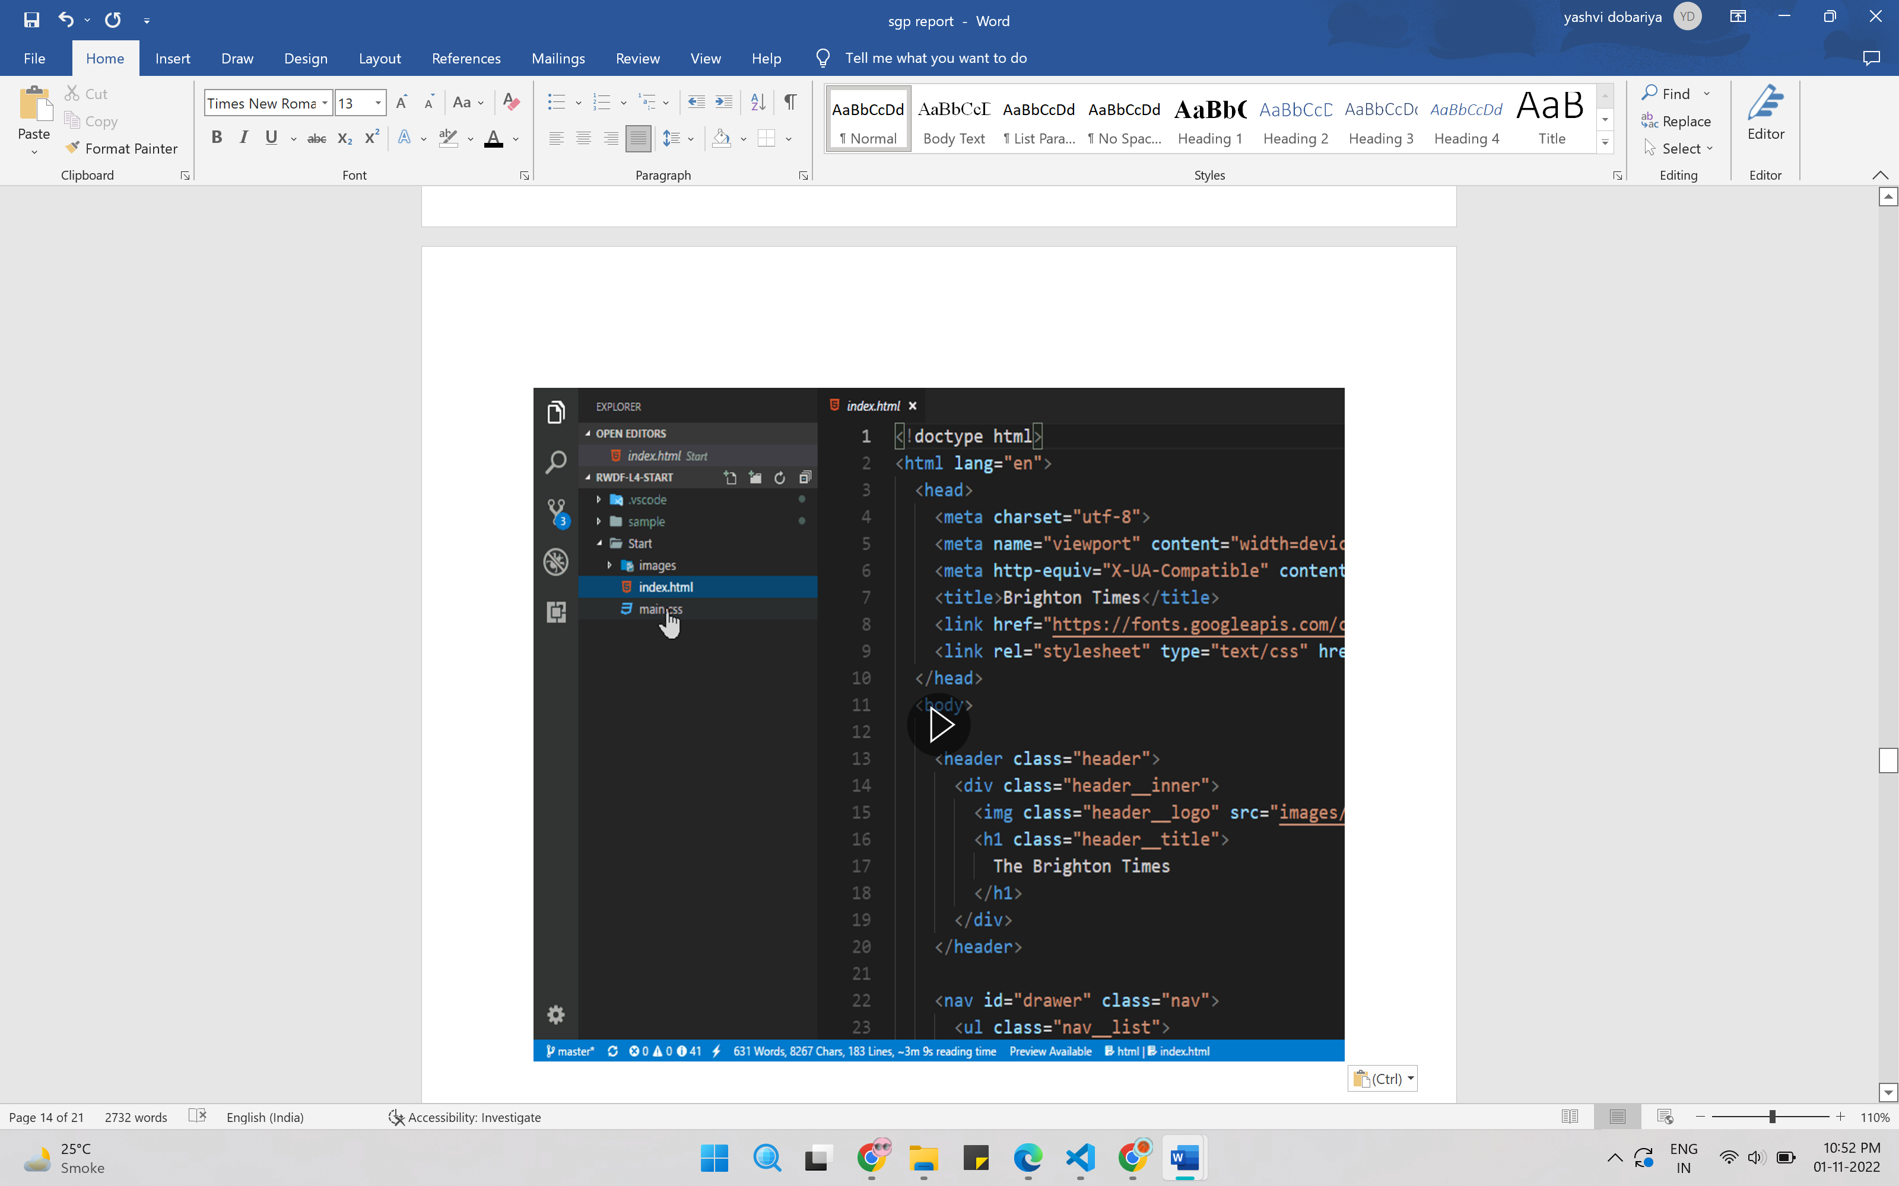

4.1 vs code files

Vs code has live server also if want to use. This view is formed by modules to provide quick access to our project's key source files.

**Basic Editing:**

Visual Studio Code is an editor first and foremost, and includes the features you need for highly productive source code editing. This topic takes you through the basics of the editor and helps you get moving with your code.

## **4.3 Vs code User Interface:**

The vs code main window contains the several logical areas which are shown in the below figure:

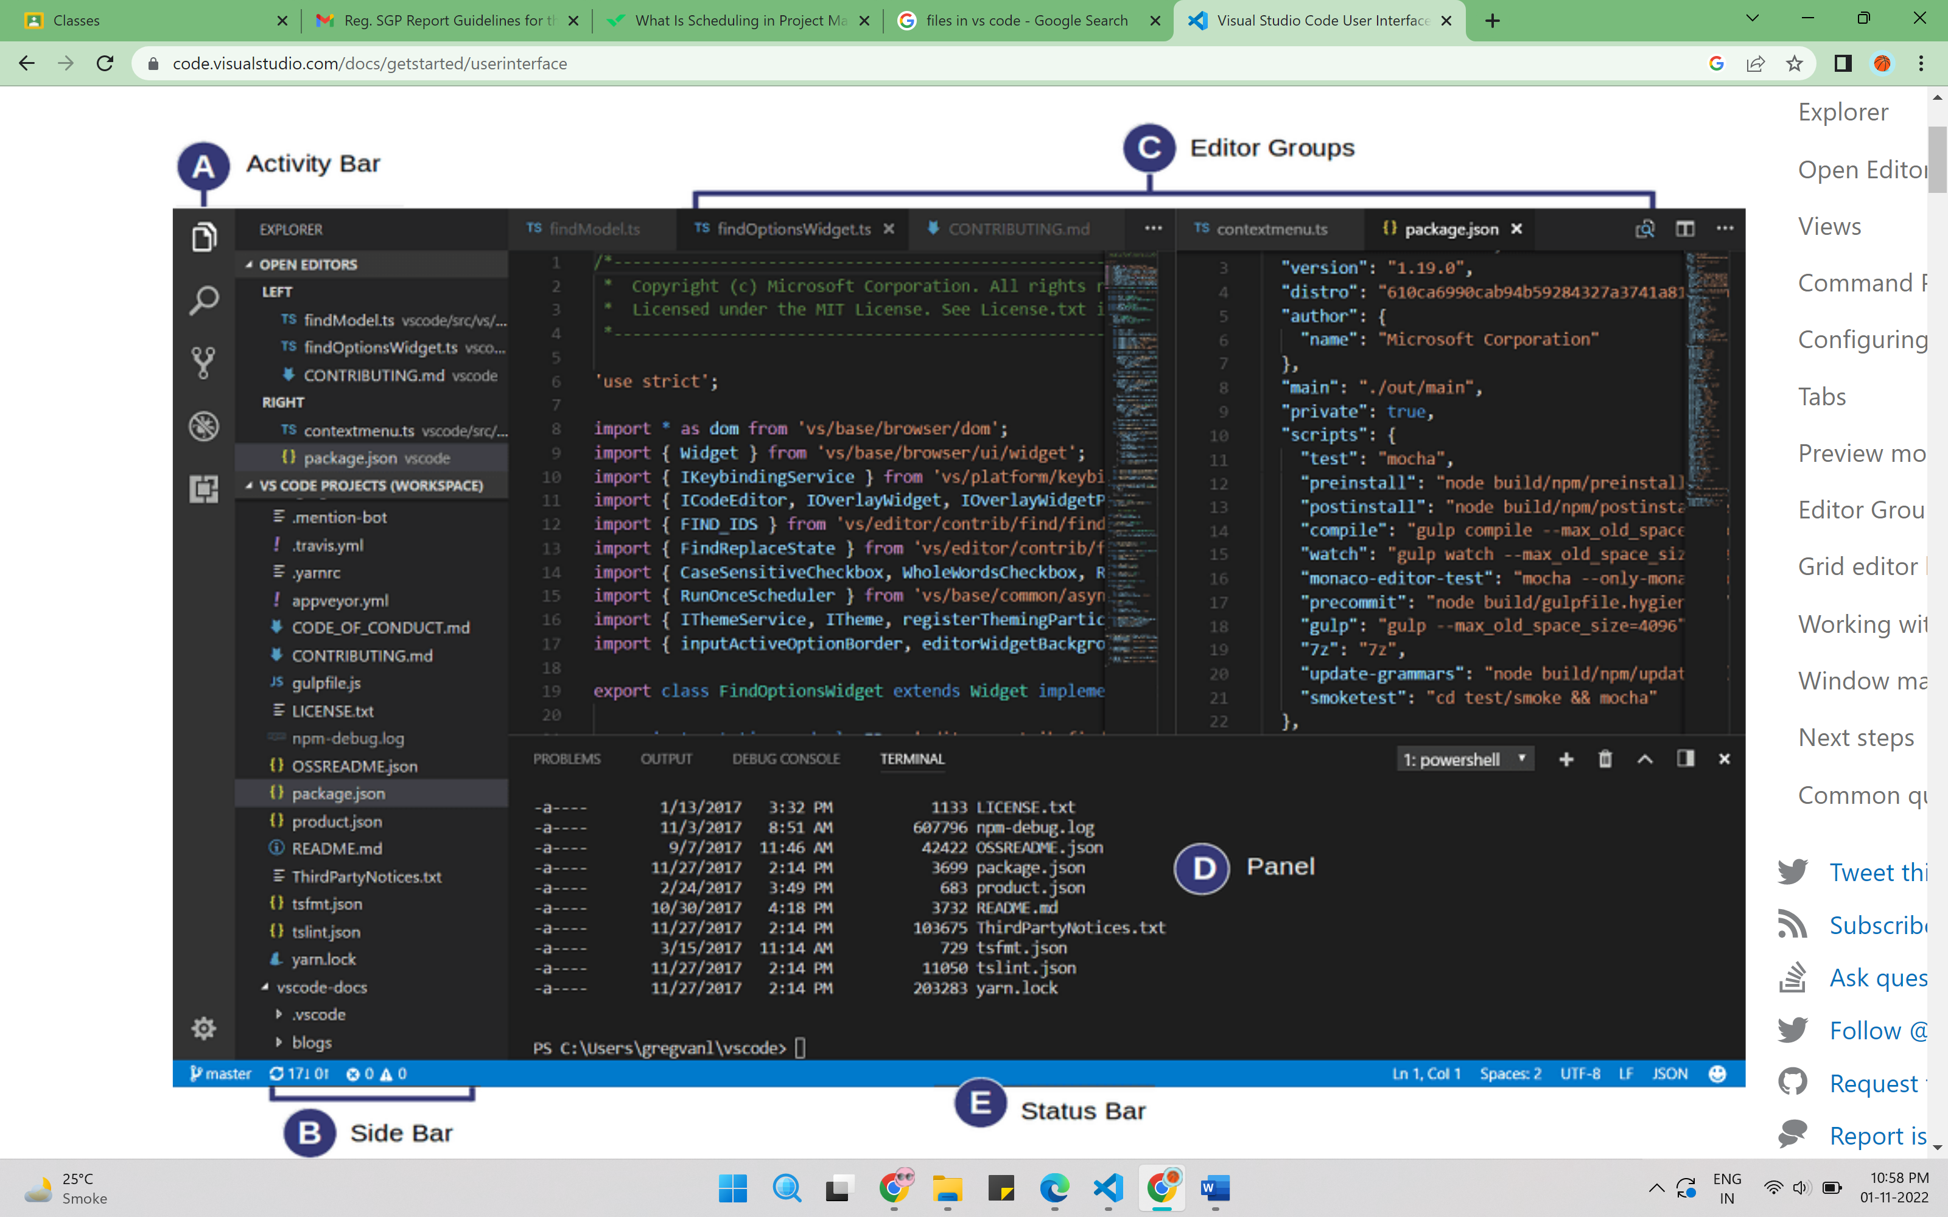

4.2 vs code user interface

**Editor** - The main area to edit your files. You can open as many editors as you like side by side vertically and horizontally.

**Side Bar** - Contains different views like the Explorer to assist you while working on your project.

**Status Bar** - Information about the opened project and the files you edit.

**Activity Bar** - Located on the far left-hand side, this lets you switch between views and gives you additional context-specific indicators, like the number of outgoing changes when Git is enabled.

**Panels** - You can display different panels below the editor region for output or debug information, errors and warnings, or an integrated terminal. Panel can also be moved to the right for more vertical space.

**Side by side editing on vs code:**

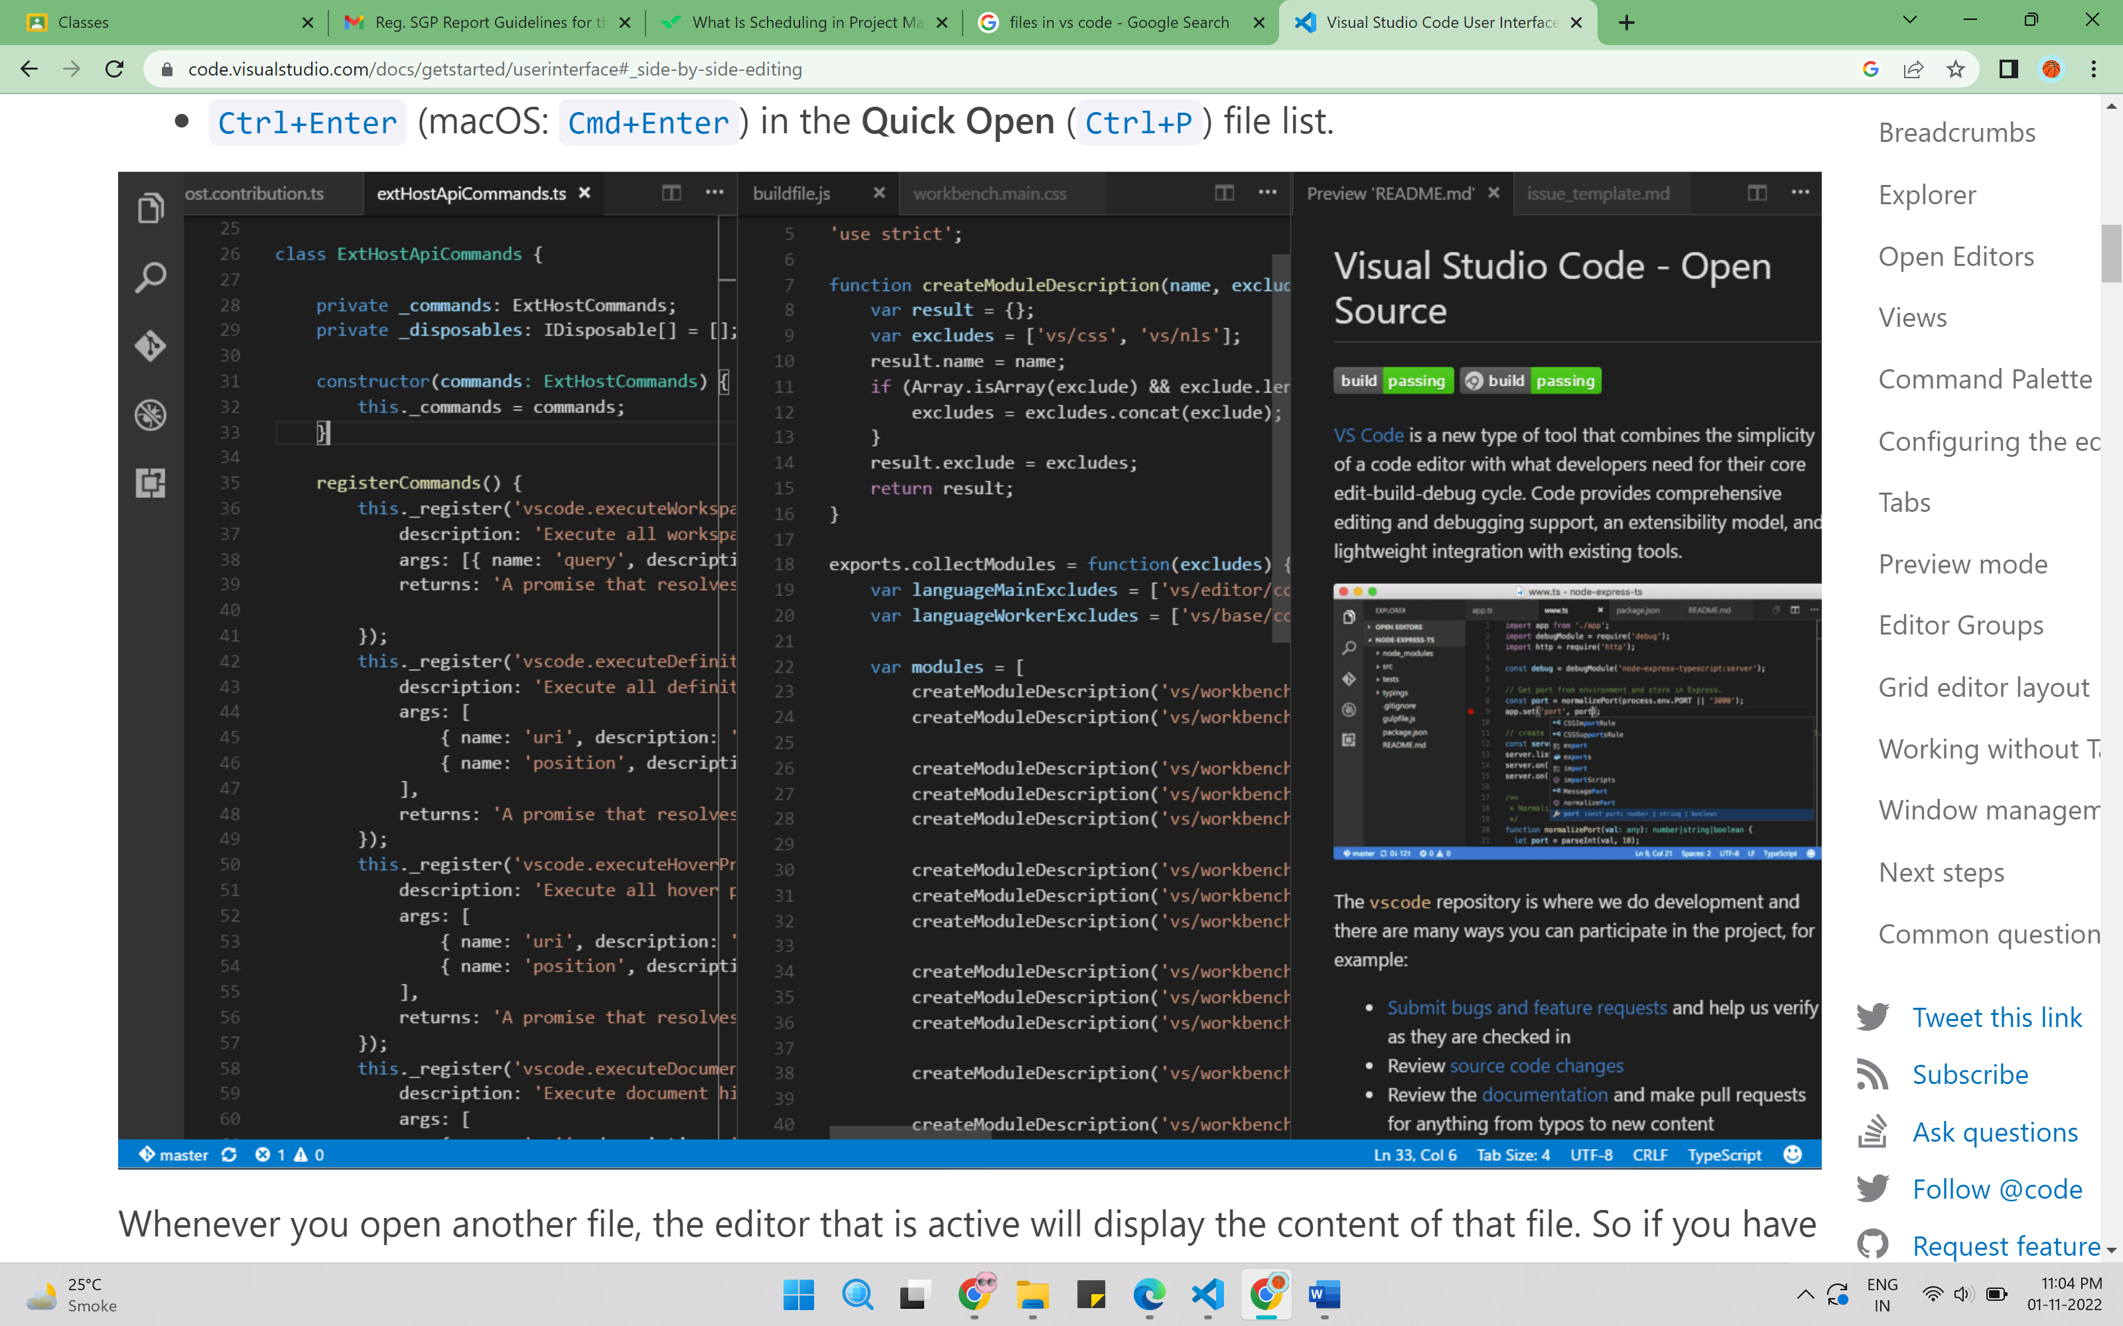

* 1. side by side coding

By default, editors will open to the right-hand side of the active one. You can change this behaviour through the setting workbench.editor.openSideBySideDirection and configure to open new editors to the bottom of the active one instead.

**CHAPTER 5: SYSTEM DESIGN**

**5.1 SCREEN LAYOUT:**

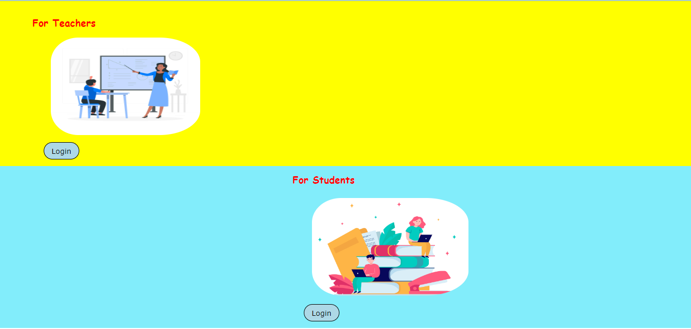

5.1 HOME PAGE

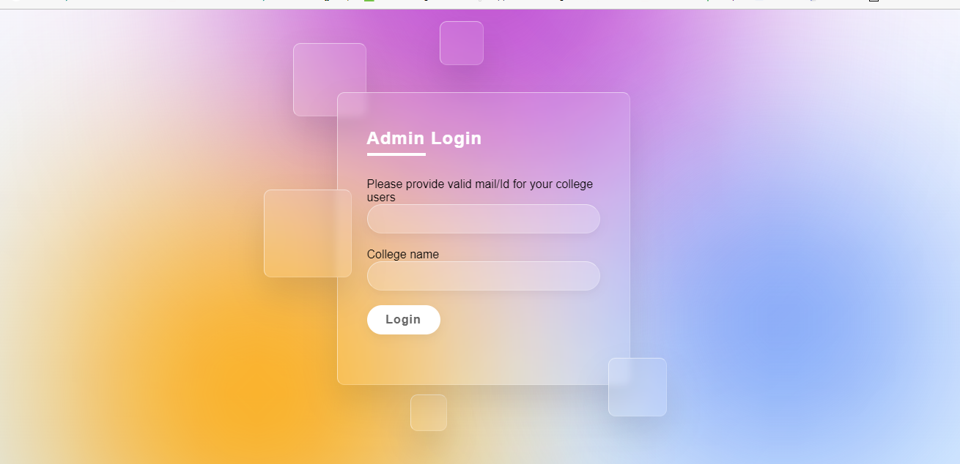

* 1. Admin login

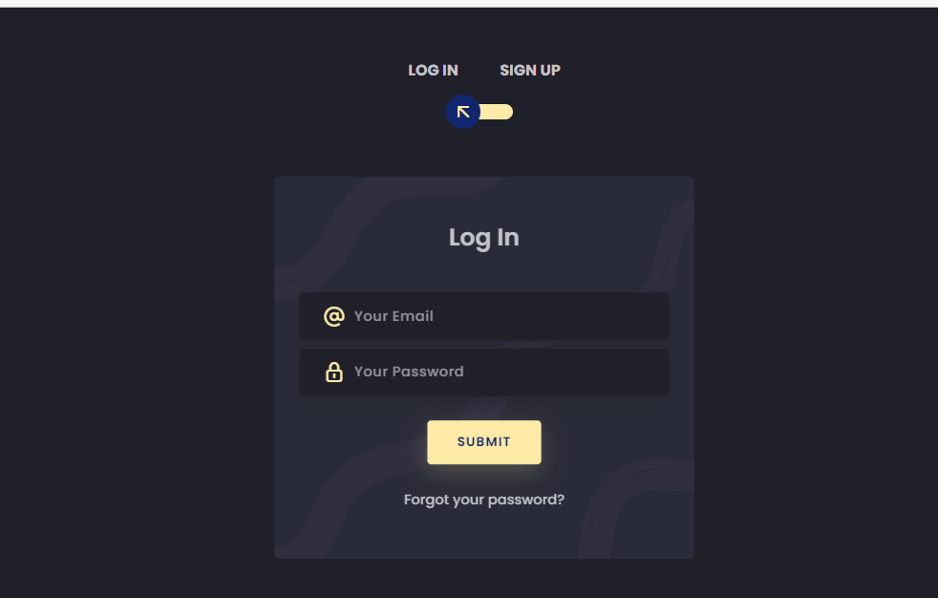

* 1. Login page

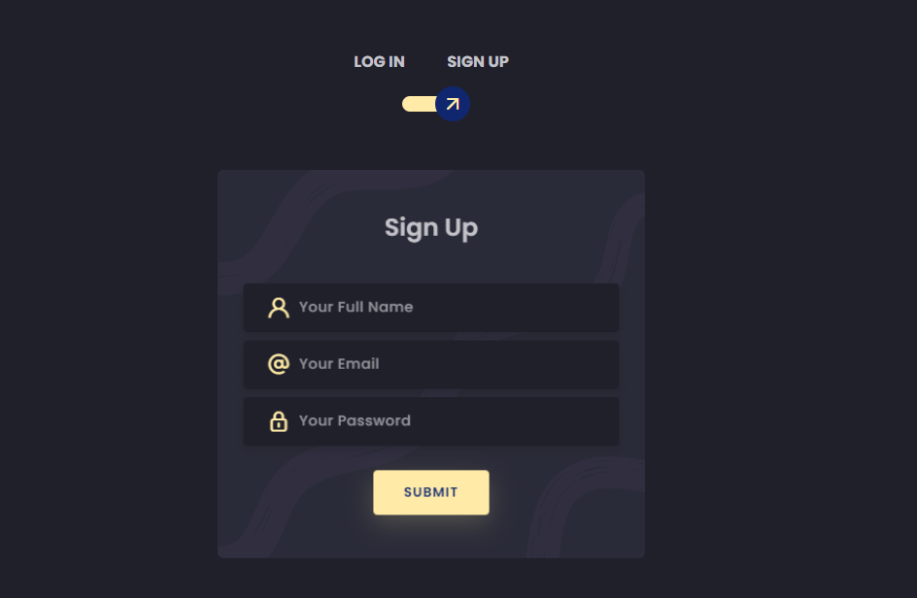

* 1. Sign Up page

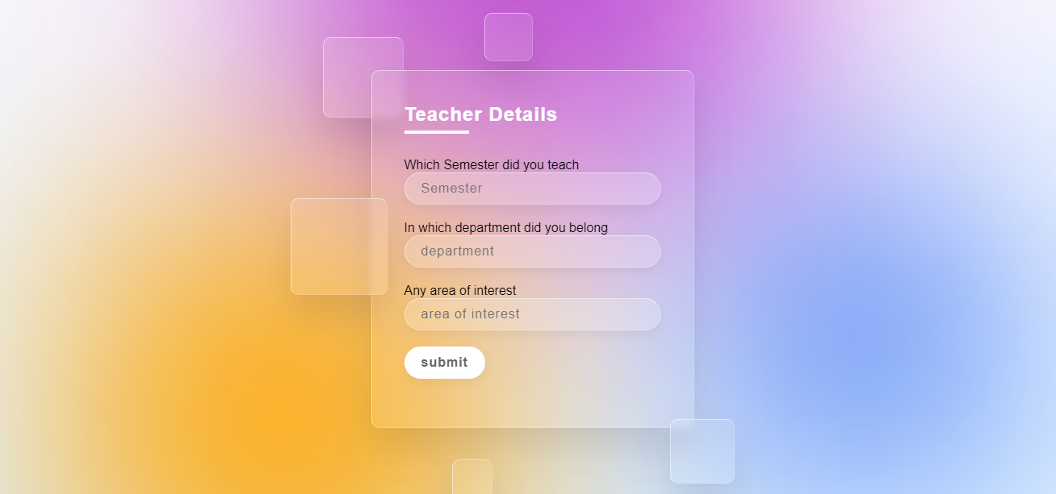

* 1. Teacher Details

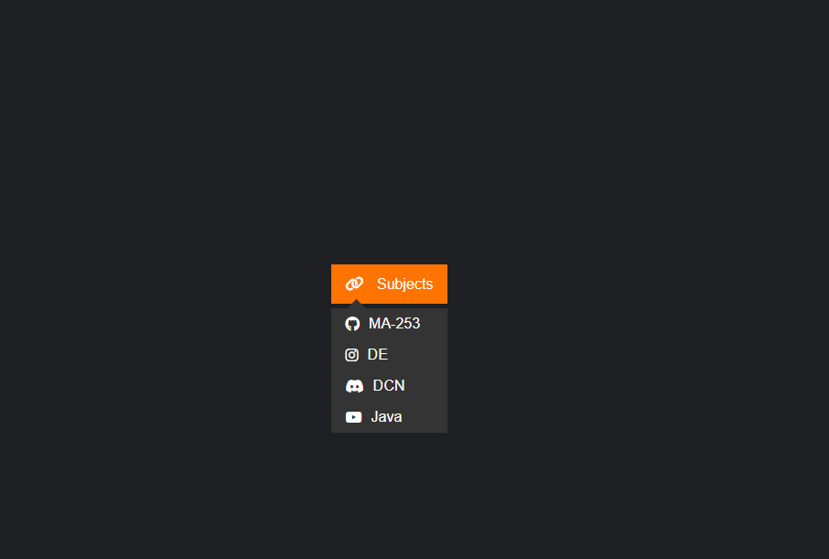

* 1. Select Subjects

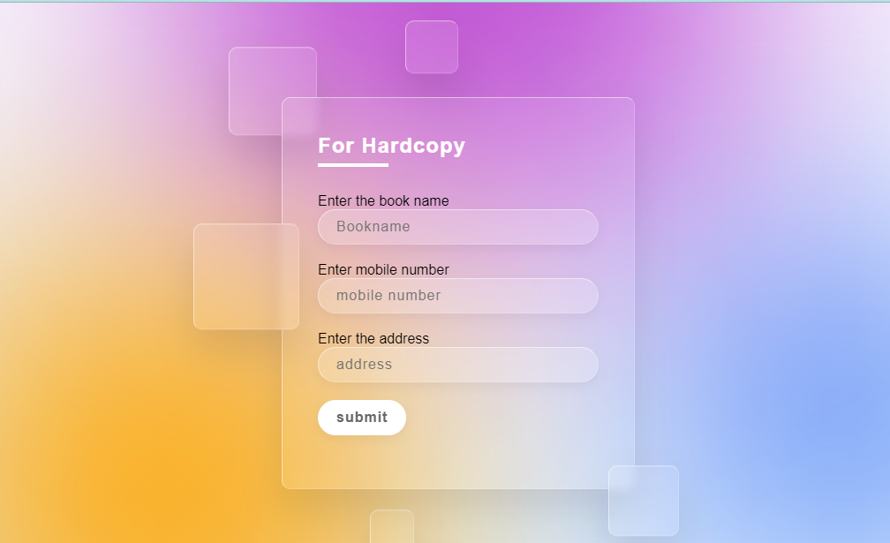

* 1. Hardcopy

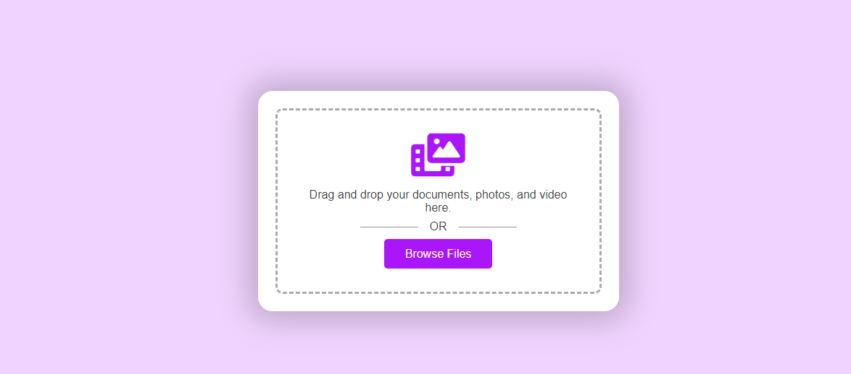

* 1. Upload the materials

**CHAPTER 6: SOFTWARE TESTING**

* 1. **WHY SOFTWARE TESTING IS NEEDED**

Tool-bars work properly? Are all menu function and pull down sub function properly listed? Is it possible to invoke each menu function using a logical assumption that if all parts of the system are correct, the goal will be successfully achieved? In adequate testing or non-testing will leads to errors that may appear few months later. Testing represents an interesting anomaly for the software engineer. During earlier software engineering activities, the engineer attempts to build software from an abstract concept to a tangible product. Now comes testing. The engineer creates a series of test cases that are intended to “demolish” the software that has been built. In fact, testing is the one step in the software process that could be viewed (psychologically, at least) as destructive rather than constructive. Testing requires that the developer discard preconceived notions of the “correctness” of software just developed and overcome a conflict of interest that occurs when errors are uncovered.

If testing is conducted successfully (according to the objectives stated previously) it will uncover errors in the software. As a secondary benefit, testing demonstrates that software functions appear to be working according to specification, that behavioral and performance requirements appear to have been met. In addition, data collected as testing is conducted provide a good indication of software reliability and some indication of software quality as a whole. But testing cannot show the absence of errors and defects, it can show only that software errors and defects are present. It is important to keep this (rather gloomy) statement in mind as testing is being conducted.

**6.2 TESTING STRATEGY**

There are types of testing that we implement. They are as follows:

While deciding on the focus of testing activities, study project priorities. For example, for an online system, pay more attention to response time. Spend more time on the features used frequently. Decide on the effort required for testing based on the usage of the system. If the system is to be used by a large number of users, evaluate the impact on users due to a system failure before deciding on the effort.

This create two problem

* Time delay between the cause and appearance of the problem.
* The effect of the system errors on files and records within the system.

The purpose of the system testing is to consider all the likely variations to which it will be suggested and push the systems to limits. The testing process focuses on the logical intervals of the software ensuring that all statements have been tested and on functional interval is conducting tests to uncover errors and ensure that defined input will produce actual results

that agree with the required results. Program level testing, modules level testing integrated and carried out.

There are two major type of testing they are:

* White Box Testing.
* Black Box Testing.

**6.2.1 White Box Testing**

White box sometimes called “Glass box testing” is a test case design uses the control structure of the procedural design to drive test case. Using white box testing methods, the following tests were made on the system

* + 1. All independent paths within a module have been exercised once. In our system, ensuring that case was selected and executed checked all case structures. The bugs that were prevailing in some part of the code where fixed
    2. All logical decisions were checked for the truth and falsity of the values.

**6.2.2 Black Box Testing**

Black box testing focuses on the functional requirements of the software. This is black box testing enables the software engineering to derive a set of input conditions that will fully exercise all functional requirements for a program. Black box testing is not an alternative to white box testing rather it is complementary approach that is likely to uncover a different class of errors that white box methods like.

* Interface errors.
* Performance in data structure.
* Performance errors.
* Initializing and termination errors.
* [Big Picture: Industry Analysis](https://flatworldknowledge.lardbucket.org/books/designing-business-information-systems-apps-websites-and-more/s13-01-big-picture-industry-analysis.html) by Unknown Author is licensed under [CC BY-SA-NC](https://creativecommons.org/licenses/by-nc-sa/3.0/)

**CHAPTER 7: FUTURE ENHANCEMENT AND LIMITATION**

# 7.1 FUTURE ENHANCEMENT

We will try overcome our limitations , so

* That admin can check weather the uploaded material is correct or not.
* Admin can delete the old data after the time when it is not in use so that the memory require less.
* Admin can check weather the details of the user is valid.
* Anyone cannot misuses the websites for any other reasons.
  1. **LIMITATION**
* User can upload anything in the websites which is not related to the study.
* Limited storage is available.

**CHAPTER 8: CONCLUSION AND SUMMARY**

## **8.1 SELF ANALYSIS OF PROJECT VIABILITIES**

According to me, this project is completed with the primary functionalities as specified earlier, but then again there is a lot more than this which can be done. So, then it is a challenge to further develop it in to full-fledged software as it was challenge to develop up to this very stage. If you do not have Daydream supported device then the system comes to a standstill. This technology is new in the market so few knowledge about it is known. Due to lack of skilled knowledge, the project cannot be fully completed so far. This technology will help a lot in the area of Virtual Reality and will provide “Like-in” environment and amazing experience.

## **8.2 SUMMARY OF PROJECT WORK**

A easy study portal is software that is designed to help the student for the study material. This is very helpful for the both students and the teachers. Here, they can upload the material or search for the study material which they want. User can also buy or sell the hardcopy of the book which they want.

* 1. **References**

# Build fast, responsive sites with Bootstrap

# <https://getbootstrap.com/>

# Bootstrap Studio

# <https://bootstrapstudio.io/>

# Code with faraz

# <https://www.codewithfaraz.com/>

# Image of the student and teacher

# <https://unsplash.com/s/photos/teacher-and-student>

# For the html and css

# <https://www.codecademy.com/catalog/language/html-css>